Mark Skidmore/Guilherme Martins

CS302 Data Structures
Fall 2008 - Dr. George Bebis

Programming Assignment 5
Due Date: 12/4/2008

I. Introduction

The primary purpose of this program is to demonstrate Inheritance and the use of a Priority Queue using a Heap. An update-able priority queue, UPQType, will be inherited from a base class, PQType. In addition to the normal functions of a priority queue, the update-able priority queue will have the ability to remove or update any item. If an item is not in the queue for either of these operations, no change to the queue will occur.

II. Program Usage

The program is simple to use. In a command window, navigate to the 5Assignment folder containing the program files. Then from the command line, simply run the executable by typing ./upqtype.bin and follow the on-screen prompts and menu as shown below in Illustration 1. The user can choose any of the menu items.

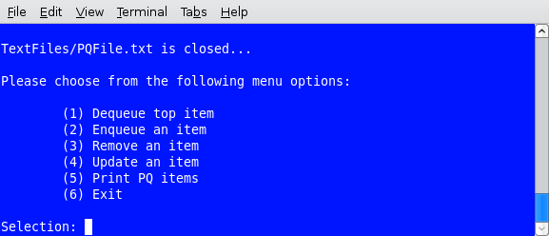Illustration 1: UPQType Menu Items

Illustration 2 shows Menu Item 1 being selected and the results. The top item is dequeued.

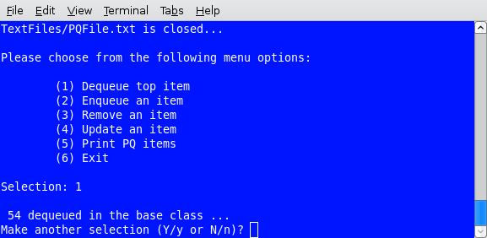Illustration 2: UPQType Menu Item 1

Illustration 3 shows Menu Item 2 being selected and the results. A new item is enqueued then heaped up.

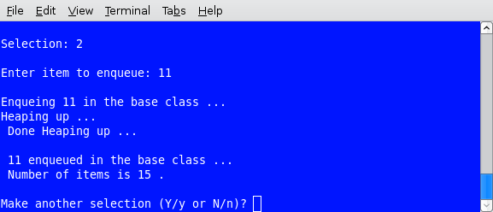Illustration 3: UPQType Menu Item 2

Illustration 4 shows Menu Item 3 being selected and the results. Item 12 is entered to be removed but is not in the queue. On the next attempt, item 11 is entered, found and removed.
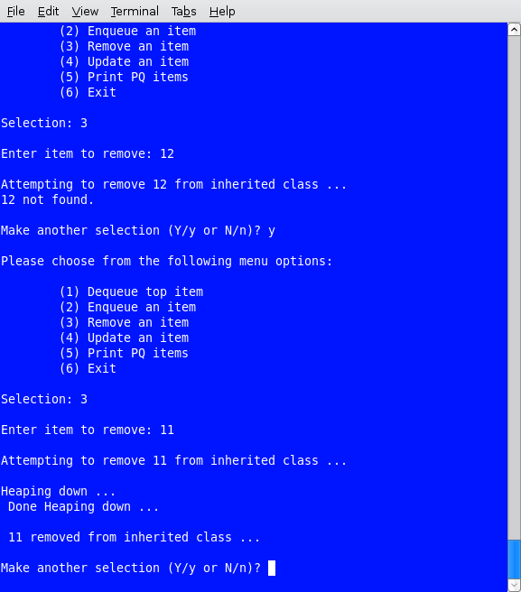Illustration 4: UPQType Menu Item 3

Illustration 5 shows Menu Item 4 being selected and the results. Item 71 is entered to be updated but is not found. Item 10 is then entered, found and updated to its new value, 17, and the que is reheaped.
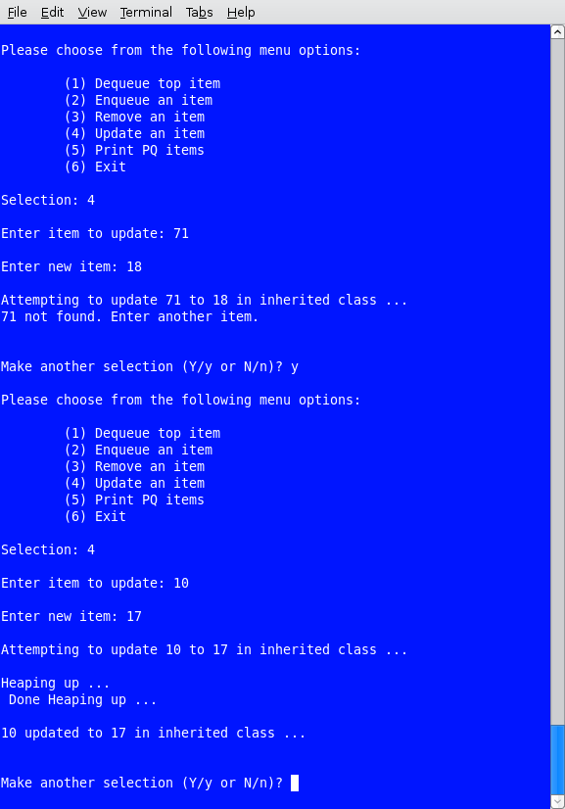Illustration 5: UPQType Menu Item 4

Illustration 6 shows Menu Item 5 being selected and the results. All of the items in the queue are displayed.

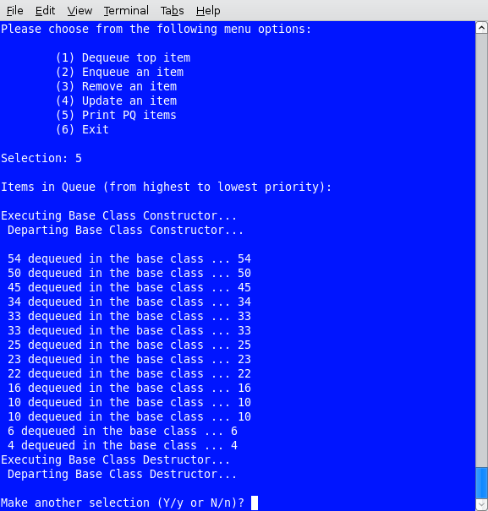Illustration 6: UPQType Menu Item 6

III. Program Implementation and Results

A. UPQmain.cpp Client Functions

UPQmain.cpp is the main driver for the program and relies on the PQType and UPQType classes which are described below.

void populateQ(UPQType&);

Called from within main; calls openFile() function which opens a text file then reads integer items from the file and enqueues them in the UPQType object. Closes the openFIle() function.

void openFile(ifstream &fin, char *textFileName);

Called from within populateQ(); opens a text file using the ifstream object, fin, and a text file name stored in textFileName.

int displayMenu();

Called from within main; displays a list of menu items to the user. Returns an integer indicating the user's choice of which menu item to execute.

int validateChoice(int choice);

Called from within displayMenu() function to validate user's choice of menu items. Ensures user enters valid menu item number. Returns the integer indicating the user's choice of which menu item to execute.

char validateResponse();

Validates the user's input to the displayMenu() function. Returns Y/y or N/n char to indicate user's choice to continue program usage (Y/y) or termination (N/n).

void executeCases(UPQType&, int);

Called from within main and remains active until the user chooses to exit. Accept and passes the user's choice (1 through 5) returned from displayMenu() and a main-declared and populated UPQType object to the executeCases() function for further user-selected processing.

B. The PQType Class (PQType.h/.cpp)

This class contains standard priority queue functions and are briefly described below.

PQType(int);

Paramaterized constructor; accepts and sets int as the maximum priority queue items. Called when a PQType or UPQType object is instantiated with an int parameter.

void Enqueue(int);

Called from within main when menu item 2 is chosen. Inserts an item into the queue then calls the ReHeapDown() function to put the item in its correct position within the queue.

void Dequeue(int&);

Called from within main when menu item 1 is chosen. Deletes an item from the queue then calls the ReHeapUp() function to put remaining items in their correct position within the queue.

bool IsEmpty() const;

Checks if the queue is empty. If member, numItems, is zero, function returns true; false otherwise.

bool IsFull() const;

Checks if the queue is full. If member, numItems, equals member, maxItems, function returns true; false otherwise.

void MakeEmpty();

Sets member, numItems, to zero.

void Print();

Displays the items in the queue to the screen. Instantiates a PQType object and calls CopyQ() function to copy existing UPQType items to PQType object then dequeues PQType items and displays them on the screen.

void Copy(PQType&);

Called from Print() function; copies UPQType items into PQType object.

virtual ~PQType();

Class destructor. Deletes heapType items declared in constructor. Implemented as virtual for inheritance purposes.

C. The UPQType Class (UPQType.h/.cpp)

The UPQType Class is inherited from the PQType class and contains the additional functions described below.

UPQType(int);

Paramaterized constructor; accepts and sets int as the maximum priority queue items. Called when a PQType or UPQType object is instantiated with an int parameter.

void Remove(int item);

Called from within main when menu item 3 is chosen. If the item to be removed is in the queue, it is removed and the queue is heaped up; otherwise, the queue remains unchanged and the user is alerted that the item to be deleted was not in the queue. The function performs the following steps:

- Set boolean, found, to false and integer counter, i, to 0
- while found is true and i is not equal to member ,numItems, search the heap
- if heap member, element, at position i is equal to item
- set found to true then copy the largest value in the heap to element i position
- decrement numItems by one
- call ReheapDown() function to restore heap order property
- if heap member, element, at position i is not equal to item, increment counter i and search again
- if heap member, element, at position i is not found, alert the user that the item is not in the queue.

This function contains the ReheapUp() function within a while loop which is based on the number of items in the queue. Therefore, the function runs on average in O(Nlog2N) time and in a worst case scenario, O(N²) time.

void Update(int oldItem, int newItem);

Called from within main when menu item 4 is chosen. If the item to be updated is in the queue, it is replaced with the new item and the queue is heaped down; otherwise, the queue remains unchanged and the user is alerted that the item to be updated was not in the queue. The function performs the following steps:

- Set boolean, found, to false and integer counter, i, to 0
- while found is true and i is not equal to member ,numItems, search the heap
- if heap member, element, at position i is equal to oldItem
- set found to true then assign newItem to heap element at position i
- call ReheapUp() function to restore heap order property
- if heap member, element, at position i is not equal to item, increment counter i and search again
- if heap member, element, at position i is not found, alert the user that the item is not in the queue.

This function contains the ReheapUp() function within a while loop which is based on the number of items in the queue. Therefore, the function runs on average in O(Nlog₂N) time and in a worst case scenario, O(N²) time.

~UPQType();

Class destructor provided for inheritance purposes.

D. The HeapType Class (HeapType.h/.cpp)

The HeapType class provides re-heaping functions for use in the PQType and UPQType classes.

void ReheapUp(int root, int bottom);

Called from within the PQType Enqueue() function after an item has been added to the heap due to . Restores the order property of the heap between its top and bottom.

void ReheapDown(int root, int bottom);

Called from within the PQType Dequeue() function after an item has been removed from the heap. Restores the order property of the heap between its top and bottom.

void Swap(int& itemOne, int& itemTwo);

Utility function used in ReHeapUp() and ReheapDown() functions.

E. Results

The program performs as required. The program is for use with integer data types only and assumes the user will use an integer list stored in a text file to populate a queue.

IV. Bugs and Errors

No bugs are errors are known as of this release.

VII. Partner Contributions.

Both partners contributed 50% each to the assignment.

